Summit Motors Dealership

CS 4347 - Professor Jamal Omer

Team Members:

Angel Jimenez, Jair Gutierrez, Vuong Nguyen, Akhil Srirangam

Date: 11/30/25

TABLE OF CONTENTS

Introduction………………………………………………………………………………………………..3

System Requirements……………………………………………………………………………………3

Conceptual Design of the Database……………………………………………………………………5

Logical Database Schema……………………………………………………………………………...11

Functional Dependencies and Database Normalization…………………………………………....16

The Database System………………………………………………………………………………….19

Suggestions on Database Tuning……………………………………………………………………..23

User Application Interface………………………………………………………………………………24

Conclusion and Future Work…………………………………………………………………………..27

References……………………………………………………………………………………………….27

Appendix………………………………………………………………………………………………....27

# **Introduction**

This project consists of developing a complete Car Dealership Database Management System capable of storing, modifying, and retrieving information related to customers, vehicles, employees, ownership, and service history.

# **System Requirements**

System architecture diagram:

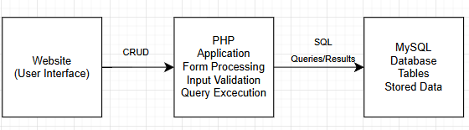

List the interface requirements of the system:

User Interface:

User Login

User Registraction

User home dashboard

Add Vehicle

Delete Vehicle

View Vehicle

Edit Vehicle Information

List the functional requirements of the database system:

User Authentication

* Register new users
* Prevent duplicate SSNs and emails
* Validate data format (SSN, phone number, VIN, etc.)

Customer Functions

* View/update personal information
* Add vehicles they own
* View all owned vehicles
* Add service requests
* View vehicle service histories

List non-functional requirements of the database system

Reliability

* CASCADE deletes where appropriate
* SET NULL where data should persist

Security

* Employ prepared SQL statements
* Use php sessions for log in

Scalability

* Support multi-location dealerships
* Allow thousands of service records

# 

# 

# 

# 

# 

# 

# **Conceptual Design of the Database**

Entity-Relationship (ER) model:

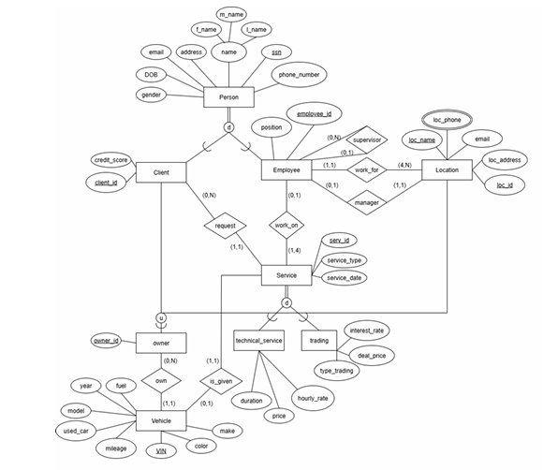

Data dictionary

Person

| Attribute | Data Type | Purpose | Default Value |
| --- | --- | --- | --- |
| ssn | char(9) | Identifier for a person | not null |
| f_name | varchar | First name | not null |
| m_intial | varchar | Middle initial | null |
| l_name | varchar | Last name | not null |
| address | varchar | Home  address | null |
| DOB | DATE | Date of birth | null |
| gender | char(1) | gender | null |
| email | varchar | Email for a person | null |
| phone_no | varchar | Phone number of a person | null |

Client

| Attribute | Data Type | Purpose | Default Value |
| --- | --- | --- | --- |
| client_id | INT | Identifier for a client | not null |
| ssn | char(9) | Links client to personal record | not null |
| Credit_score | INT | Credit rating for client | null |
| owner_id | INT | Link to id of owner | null |

Employee

| Attribute | Data Type | Purpose | Default Value |
| --- | --- | --- | --- |
| Employee_id | INT | Identifier for  employees | not null |
| ssn | char(9) | Links employee to personal records | not null |
| position | varchar | Job title/role | null |
| surpevisor_id | char(9) | SSN of employees supervisor | null |
| location_no | varchar | Links employee to the location they work at | not null |
| service_id | INT | Link employee to service they are currently working on | null |

Location

| Attribute | Data Type | Purpose | Default Value |
| --- | --- | --- | --- |
| loc_name | varchar | Name of location | not null |
| loc_no | INT | Identifier for the location | not null |
| loc_email | varchar | Contact email of location | null |
| loc_address | varchar | Physical address of location | null |
| manager_id | varchar | Manager of the location links to  employee | not null |
| owner_id | INT | Location is the owner of a vehicle (until sold) | - |

Location_Phone

| Attribute | Data Type | Purpose | Default Value |
| --- | --- | --- | --- |
| loc_no | INT | Identifier of the location | not null |
| loc_phone | varchar | Location contact number | not null |

Vehicle

| Attribute | Data Type | Purpose | Default Value |
| --- | --- | --- | --- |
| VIN | char(17) | Identifier for the vehicle | not null |
| fuel | varchar | Fuel type of the vehicle | null |
| make | varchar | Manufacturer of the vehicle | null |
| model | varchar | Model of the vehicle | null |
| year | YEAR | Year of the car | null |
| color | varchar | Color of the car | null |
| milage | INT | Mileage of the vehicle | 0 |
| used | BOOLEAN | Is the vehicle used or new | false |
| owner_id | INT | Link to the person who owns the vehicle | null |

Services

| Attribute | Data Type | Purpose | Default Value |
| --- | --- | --- | --- |
| serv_id | INT | Identifier for the a service given | not null |
| serv_type | varchar | Type of service given | null |
| serv_date | DATE | Date service is performed | null |
| client_id | INT | Links the service to a client | not null |
| VIN | char(17) | Links the vehicle getting the service | null |

Technical Service

| Attribute | Data Type | Purpose | Default Value |
| --- | --- | --- | --- |
| serv_id | INT | Identifier for the service given links it with services | not null |
| duration | INT | Duration of the service in minutes | 0 |
| hourly_rate | DECIMAL  (10,2) | Hourly labor rate for  employee | 0.00 |
| price | DECIMAl  (10,2) | Cost of the service | 0.00 |

Trading

| Attribute | Data Type | Purpose | Default Value |
| --- | --- | --- | --- |
| serv_id | INT | Identifier for the service given links it with services | not null |
| type_trading | varchar | Type of trade (buy/sell) | null |
| interest_rate | DECIMAL  (4,2) | Interest rate applied to trade details | 0.00 |
| deal_price | DECIMAL  (10,2) | Total deal amount | 0.00 |

Owner

| Attribute | Data Type | Purpose | Default Value |
| --- | --- | --- | --- |
| Owner_id | INT | Identifier of the owner of the  vehicle (client / dealership) | not null |

Business Rules

* A Person may be a Client or Employee.
* Each Client has an owner_id; deleting a Person cascades.
* A Vehicle belongs to an Owner, not directly a Person.
* A Service is linked to both a Client and a Vehicle.
* A Technical Service or Trading record is created only when a Service occurs.
* A Location may have multiple employees and phone numbers.
* Deleting a Person removes them as client or employee automatically.

# 

# **Logical Database Schema**

Relational Schema

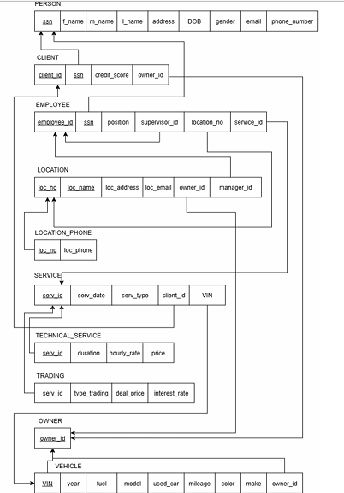

SQL statements

CREATE DATABASE IF NOT EXISTS car_dealership;

USE car_dealership;

-- Create Person table

CREATE TABLE IF NOT EXISTS Person (

ssn VARCHAR(11) PRIMARY KEY,

f_name VARCHAR(50),

m_intial VARCHAR(1),

l_name VARCHAR(50),

address VARCHAR(100),

state VARCHAR(2),

DOB VARCHAR(10),

gender VARCHAR(1),

email VARCHAR(100),

phone VARCHAR(12)

);

-- Create owner table

CREATE TABLE IF NOT EXISTS owner (

owner_id INT PRIMARY KEY

);

-- Create Location table

CREATE TABLE IF NOT EXISTS Location (

loc_name VARCHAR(50),

loc_no INT PRIMARY KEY,

loc_email VARCHAR(100),

loc_address VARCHAR(100),

state VARCHAR(2),

manager_id INT,

owner_id INT

);

-- Create Location_Phone table

CREATE TABLE IF NOT EXISTS Location_Phone (

loc INT,

loc_phone VARCHAR(12),

FOREIGN KEY (loc) REFERENCES Location(loc_no)

);

-- Create Client table

CREATE TABLE IF NOT EXISTS Client (

client_id INT PRIMARY KEY,

ssn VARCHAR(11),

credit_score INT,

owner_id INT,

FOREIGN KEY (ssn) REFERENCES Person(ssn),

FOREIGN KEY (owner_id) REFERENCES owner(owner_id)

);

-- Create Employee table

CREATE TABLE IF NOT EXISTS Employee (

Employee_id INT PRIMARY KEY,

ssn VARCHAR(11),

position VARCHAR(20),

supervisor_id INT,

location_no INT,

service_id INT,

FOREIGN KEY (ssn) REFERENCES Person(ssn),

FOREIGN KEY (location_no) REFERENCES Location(loc_no)

);

-- Create Vehicle table

CREATE TABLE IF NOT EXISTS Vehicle (

VIN VARCHAR(17) PRIMARY KEY,

fuel VARCHAR(20),

make VARCHAR(50),

model VARCHAR(1),

year INT,

color VARCHAR(20),

milage INT,

used BOOLEAN,

owner_id INT,

FOREIGN KEY (owner_id) REFERENCES owner(owner_id)

);

-- Create Service table

CREATE TABLE IF NOT EXISTS Service (

serv_id INT PRIMARY KEY,

serv_type VARCHAR(20),

serv_date VARCHAR(10),

client_id INT,

VIN VARCHAR(17),

FOREIGN KEY (client_id) REFERENCES Client(client_id),

FOREIGN KEY (VIN) REFERENCES Vehicle(VIN)

);

-- Create technical_service table

CREATE TABLE IF NOT EXISTS technical_service (

serv_id INT PRIMARY KEY,

duration INT,

hourly_rate DECIMAL(10,2),

price DECIMAL(10,2),

FOREIGN KEY (serv_id) REFERENCES Service(serv_id)

);

-- Create trading table

CREATE TABLE IF NOT EXISTS trading (

serv_id INT PRIMARY KEY,

type_trading VARCHAR(10),

interest_rate DECIMAL(5,2),

deal_price DECIMAL(10,2),

FOREIGN KEY (serv_id) REFERENCES Service(serv_id)

);

The Summit Motors database system is designed primarily for supporting daily dealership operations. The expected operations are categorized by their CRUD (Create, Read, Update, Delete) nature:

* INSERT Operations (High Frequency):
  + Service Logging: Creating new service records (Service, Technical_Service) each time a customer brings a vehicle in for maintenance.
  + Client Registration: Adding new customers (Person, Client) during vehicle purchase or service intake.
  + Inventory Management: Adding new vehicles (Vehicle) to the database when shipments arrive from the manufacturer.
* UPDATE Operations (Medium Frequency):
  + Vehicle Status: Updating vehicle details (e.g., changing mileage after a test drive or updating condition from "New" to "Used").
  + Ownership Transfer: Updating the owner_id on a vehicle record when a car is sold to a client.
  + Profile Management: Updating client contact information (phone, email) or employee job titles (Employee position).
* DELETE Operations (Low Frequency):
  + Inventory Removal: Removing vehicle records that are auctioned off or scrapped.
  + Data Correction: Removing erroneous entries created by administrative mistakes.
  + Personnel Changes: Removing employee records upon termination (handled via cascading deletes from the Person table).
* SELECT / QUERY Operations (Very High Frequency):
  + Inventory Search: Customers and staff searching for vehicles by Make, Model, or VIN.
  + History Retrieval: Retrieving the complete service history for a specific VIN during a maintenance visit.
  + Authentication: Verifying user credentials (email and password) during the login process.

Based on the operational scale of a mid-sized regional dealership with multiple locations, we estimate the following data growth rates:

* Clients: Expected to handle an initial load of 2,000 client records, with a growth rate of approximately 50–100 new clients per month.
* Vehicles: The active inventory will maintain approximately 300–500 vehicles at any given time. However, the historical table of sold vehicles will grow by 40–60 records per month.
* Service Records: This will be the fastest-growing segment of the database. Assuming 15 service appointments per day across two locations, we anticipate adding ~4,500 service records annually.
* Employees & Locations: These tables are relatively static, containing fewer than 100 records combined, with infrequent updates.

# **Functional Dependencies and Database Normalization**

Person

PK: ssn

FD: ssn → f_name, m_initial, l_name, address, DOB, gender, email, phone_no

Analysis:

1NF: All values are atomic

2NF: Non-composite PK, partial dependencies are impossible

3NF: No transitive dependencies exist

Client

PK: client_id

FD: client_id → ssn, Credit_score, owner_id

ssn (candidate key, Person specialization) → client_id, Credit_score, owner_id

Analysis:

1NF: All values are atomic

2NF: Non-composite PK, partial dependencies are impossible

3NF: Only non-prime attributes are Credit_score and FKs. No non-prime attribute determines another non-prime attribute

Employee

PK: Employee_id

FD: Employee_id → ssn, position, supervisor_id, location_no, service_id

ssn (candidate key, Person specialization) → Employee_id, position, supervisor_id, location_no, service_id

Analysis:

1NF: All valuates are atomic

2NF: Non-composite PK, partial dependencies are impossible

3NF: Only non-prime attributes are position and FKs. No non-prime attribute determines another non-prime attribute

Location

PK: loc_no

FD: loc_no → loc_name, loc address, loc_email, manager_id, owner_id

Analysis:

1NF: All values are atomic

2NF: Non-composite PK, partial dependencies are impossible

3NF: No transitive dependencies exist

Location_phone

PK: loc_no

loc_phone

FD: none

Analysis:

1NF: All values are atomic

2NF: No non-prime attributes, partial dependencies are impossible

3NF: No non-prime attributes, transitive dependencies are impossible

Vehicle

PK: VIN

FD: VIN → year, fuel, model, used_car, mileage, color, make, owner_id

Analysis:

1NF: All values are atomic

2NF: Non-composite PK, partial dependencies are impossible

3NF: No transitive dependencies exist

Owner

PK:owner_id

FD: None

Analysis:

1NF: All values are atomic

2NF: No non-prime attributes, partial dependencies are impossible

3NF: No non-prime attributes, transitive dependencies are impossible

Service

PK: service_id

FD: serv_id → serv_date, serv_type, client_id, VIN

Analysis:

1NF: All values are atomic

2NF: Non-composite PK, partial dependencies are impossible

3NF: Only non-prime attributes are FKs (VIN, client_id) which don’t

depend on each other. No non-prime attribute determines another non-prime attribute

Technical_service

PK: serv_id

FD: serv_id → duration, hourly_rate, price

Analysis:

1NF: All attributes are atomic

2NF: Non-composite PK, partial dependencies are impossible

3NF: No transitive dependencies exist

Trading

PK: serv_id

FD: serv_id → type_trading, deal_price, interest_rate

Analysis:

1NF: All attributes are atomic

2NF: Non-composite PK, partial dependencies are impossible

3NF: No transitive dependencies exist

# **The Database System**

System Installation: The database backend is built on MySQL. To install the system, the schema is initialized using a master SQL script (summit.sql). This script performs the following actions:

* Schema Creation: Initializes the summit_motors_db database.
* Table Definition: Creates the 10 core relational entities (including Person, Vehicle, Location, and Service) with Foreign Key constraints to maintain referential integrity.
* Data Seeding: Populates the tables with initial dummy data (e.g., dealership locations, demo users, and vehicle inventory) to ensure the system is ready for immediate testing.

Configuration Connectivity between the user interface and the database is managed by the db_connect.php module. This file contains the specific credentials (hostname, username, and password) required to authenticate the PHP application against the local MySQL instance.

System Invocation: The system is invoked by launching a local PHP development server.

Command: php -S localhost:8000 (on Mac Terminal)

Access: Once the server is listening, the full database system is accessible via a standard web browser at http://localhost:8000/login.html.

Operation: The application remains active as long as the terminal window running the PHP server remains open. Closing the terminal terminates the system invocation.

Screenshot Dump:

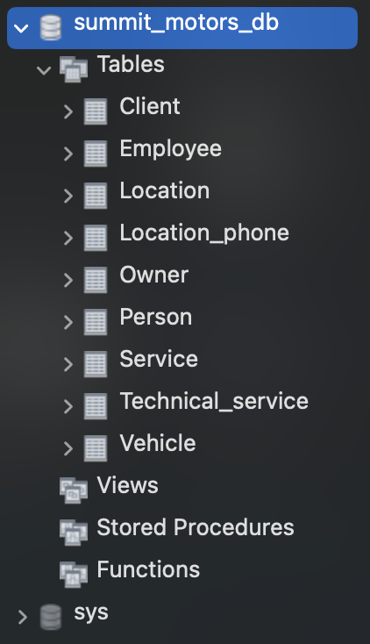

Figure 1: MySQL Schema after running summit.sql

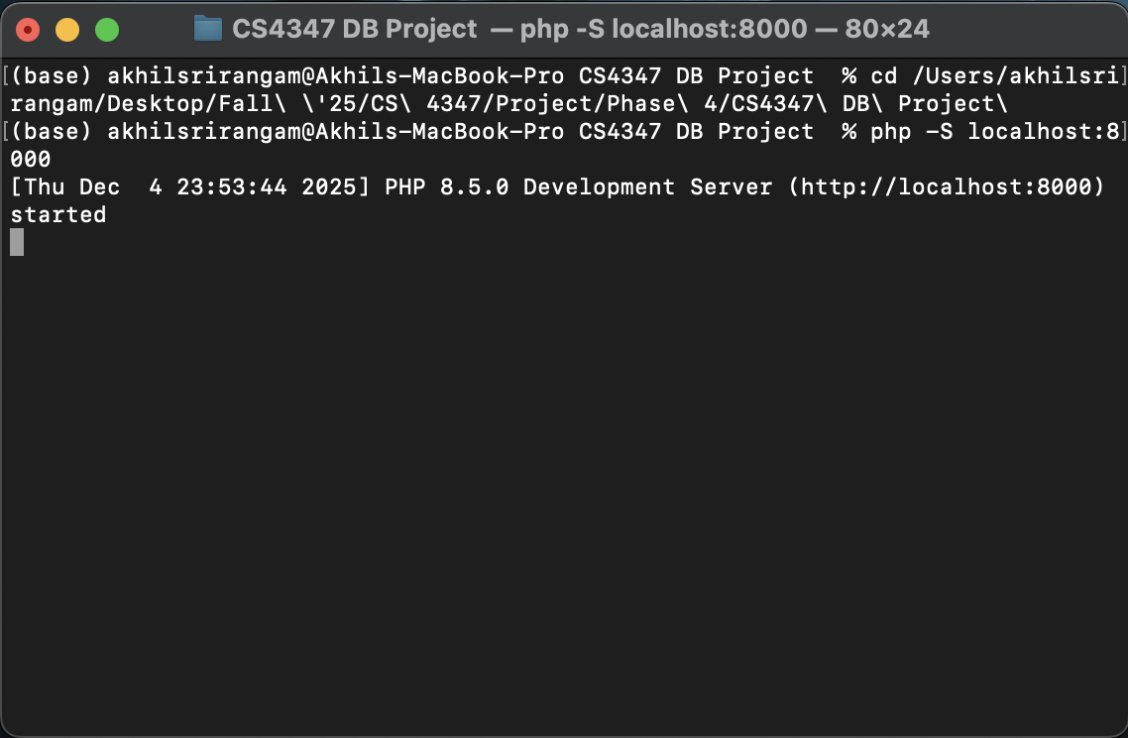

Figure 2: Initializing the local PHP development server via Terminal.

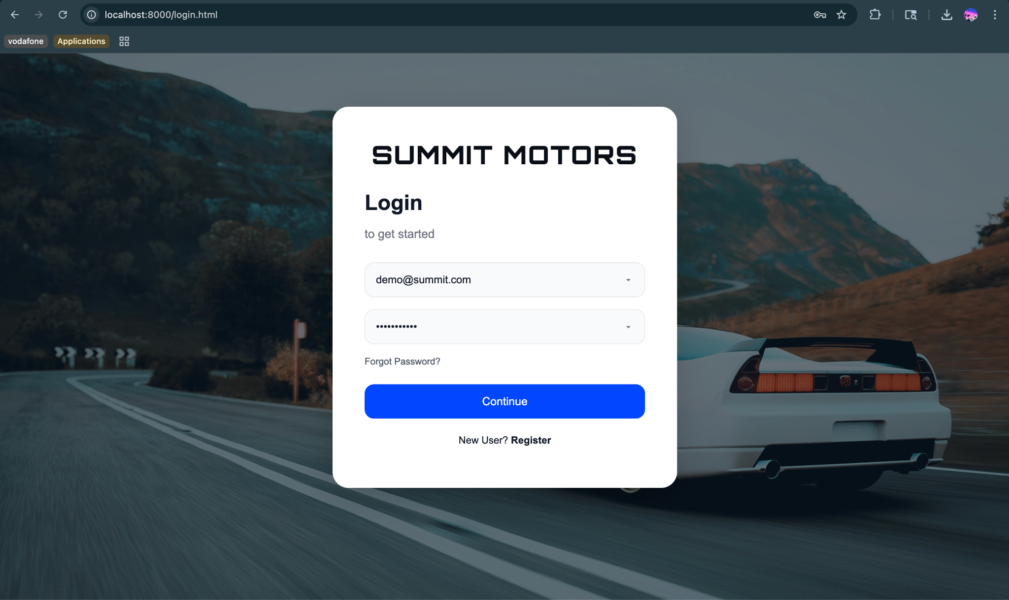

Figure 3: The secure user login interface.

Login with username: [demo@summit.com](mailto:demo@summit.com), password: password123

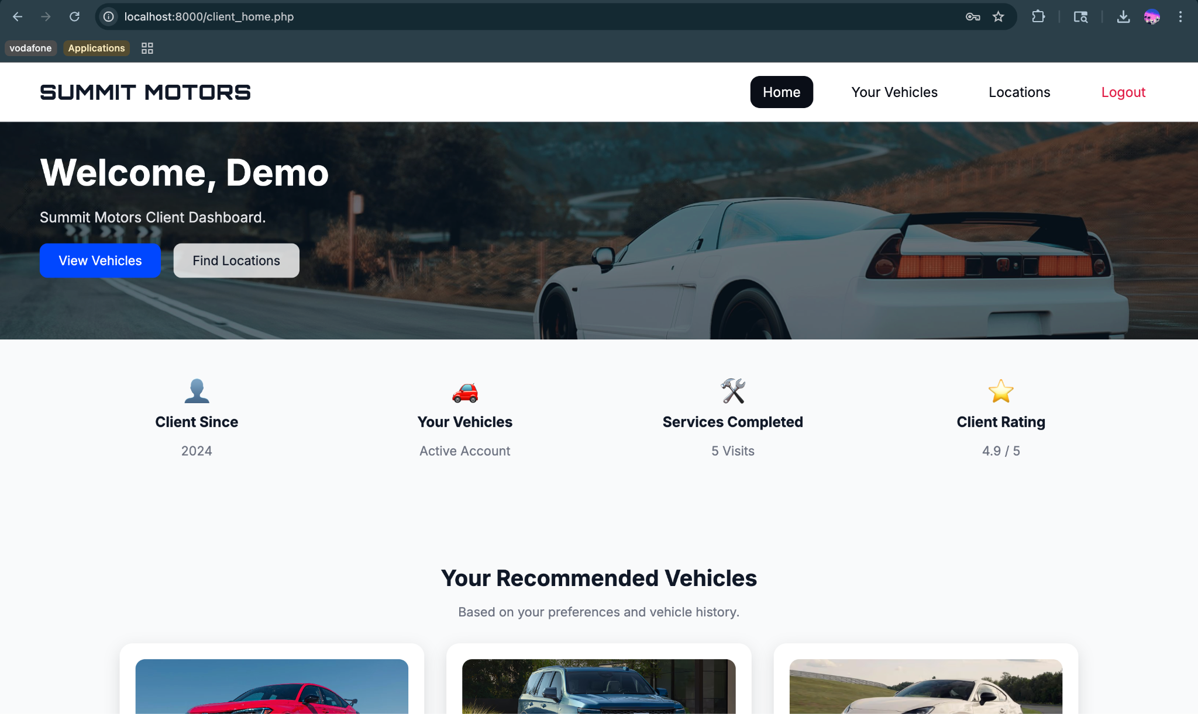

Figure 4: Client Dashboard displaying personalized user session data.

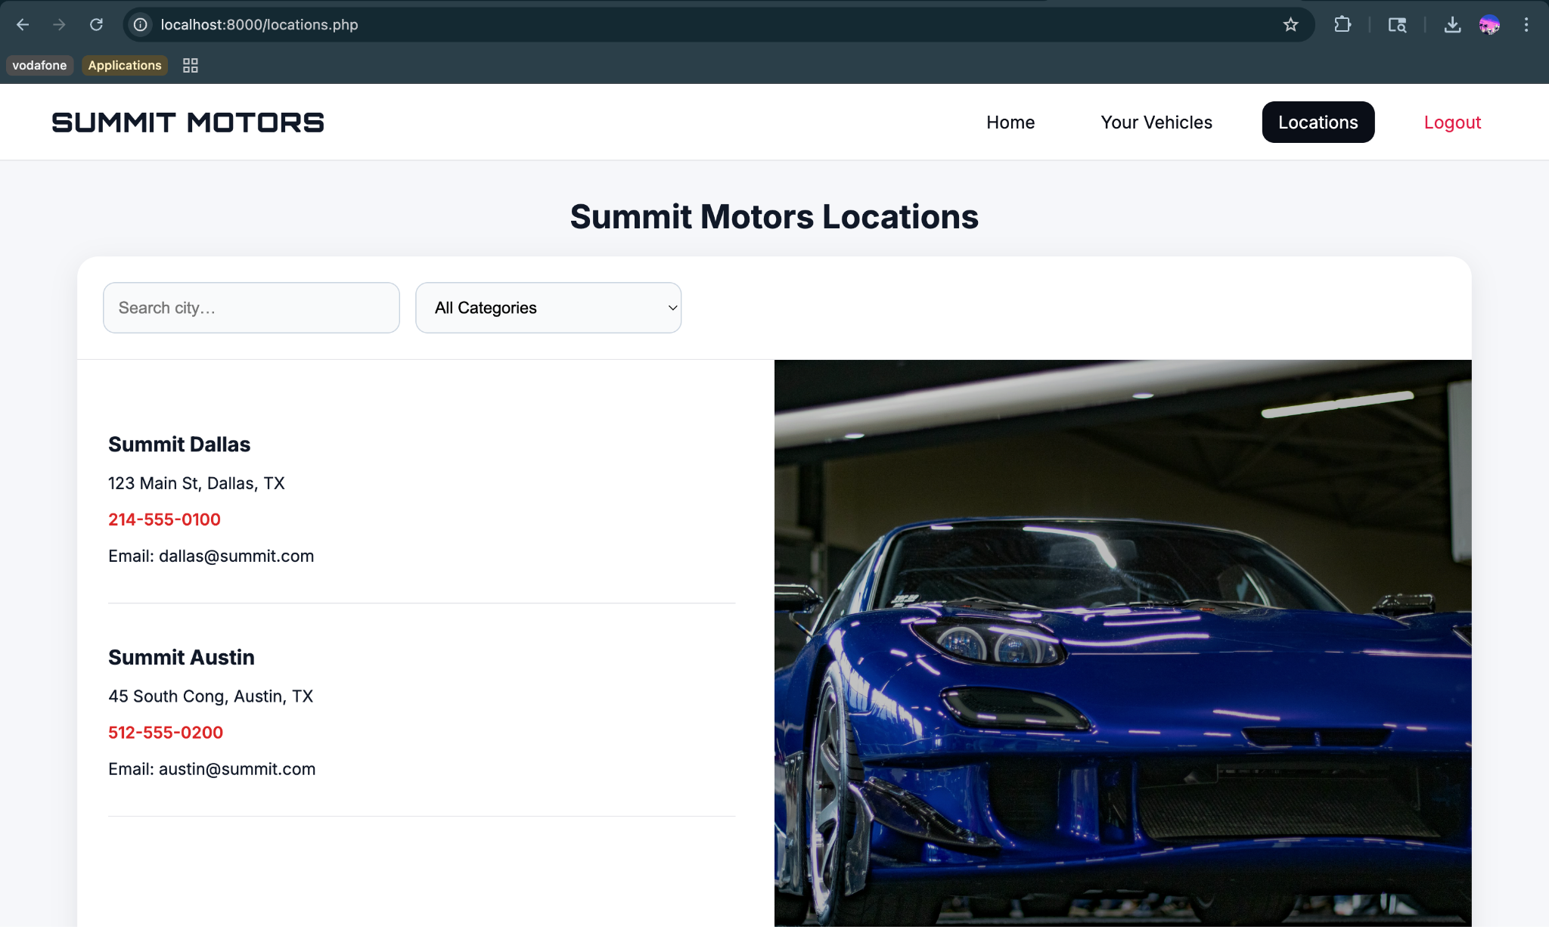

Figure 5: Locations page retrieving dealership information dynamically from the database.

CRUD Operations:

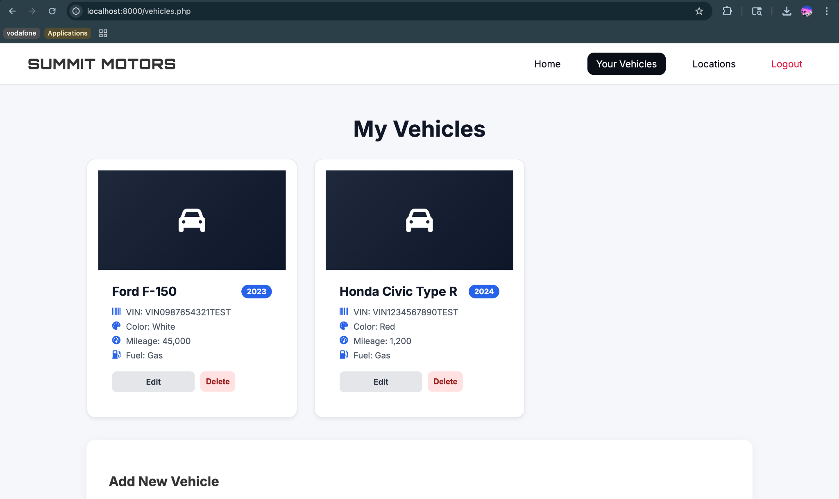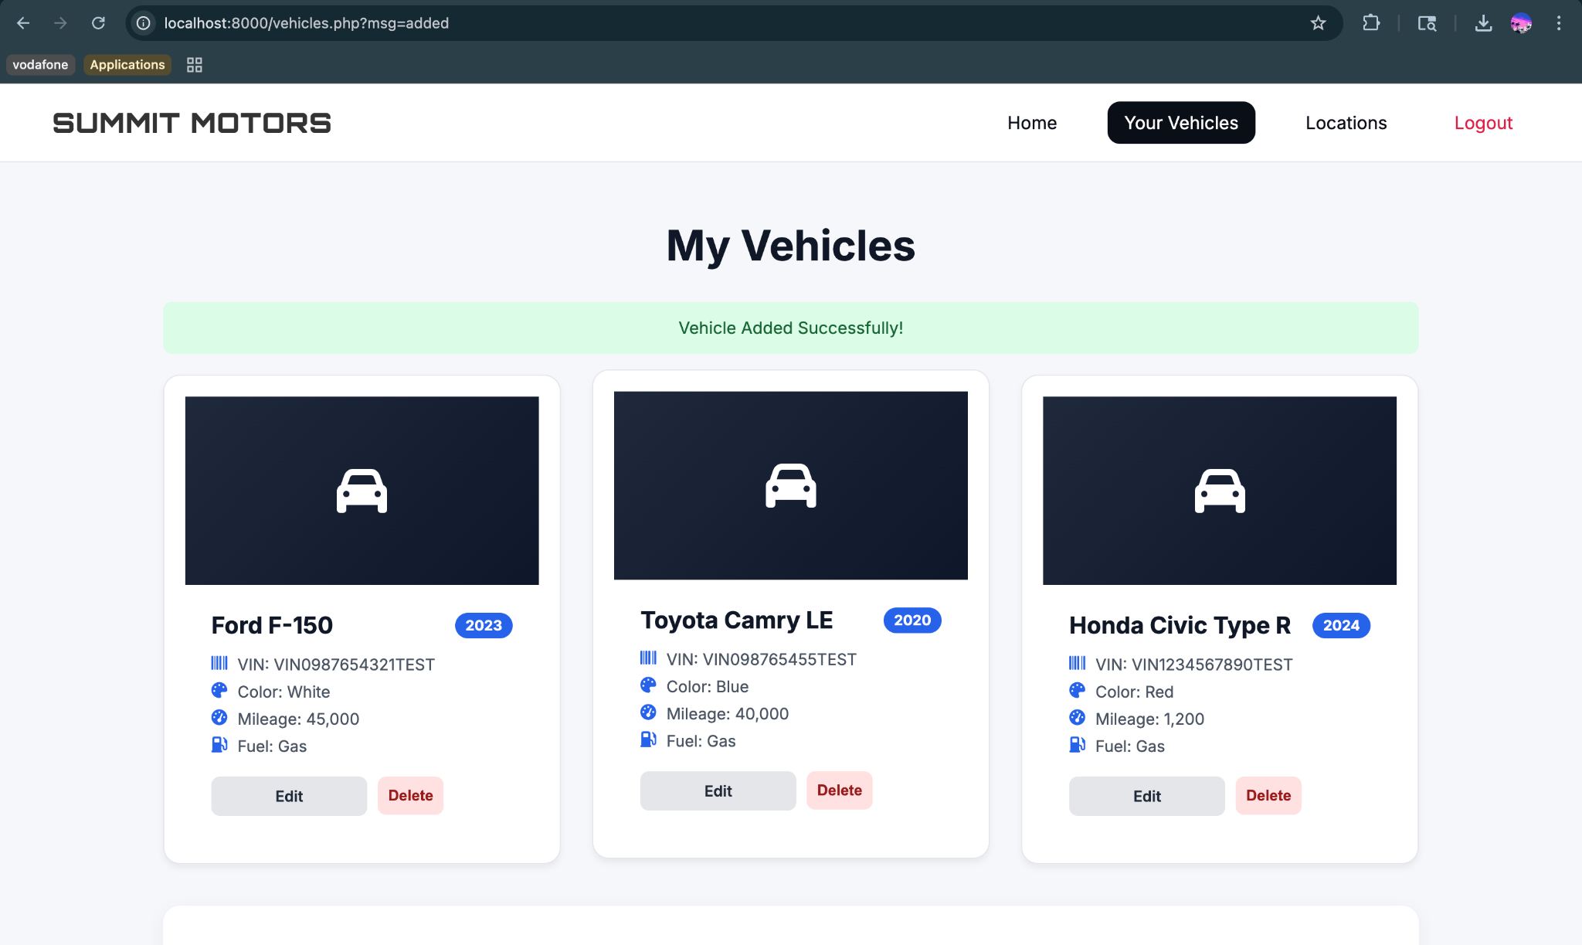

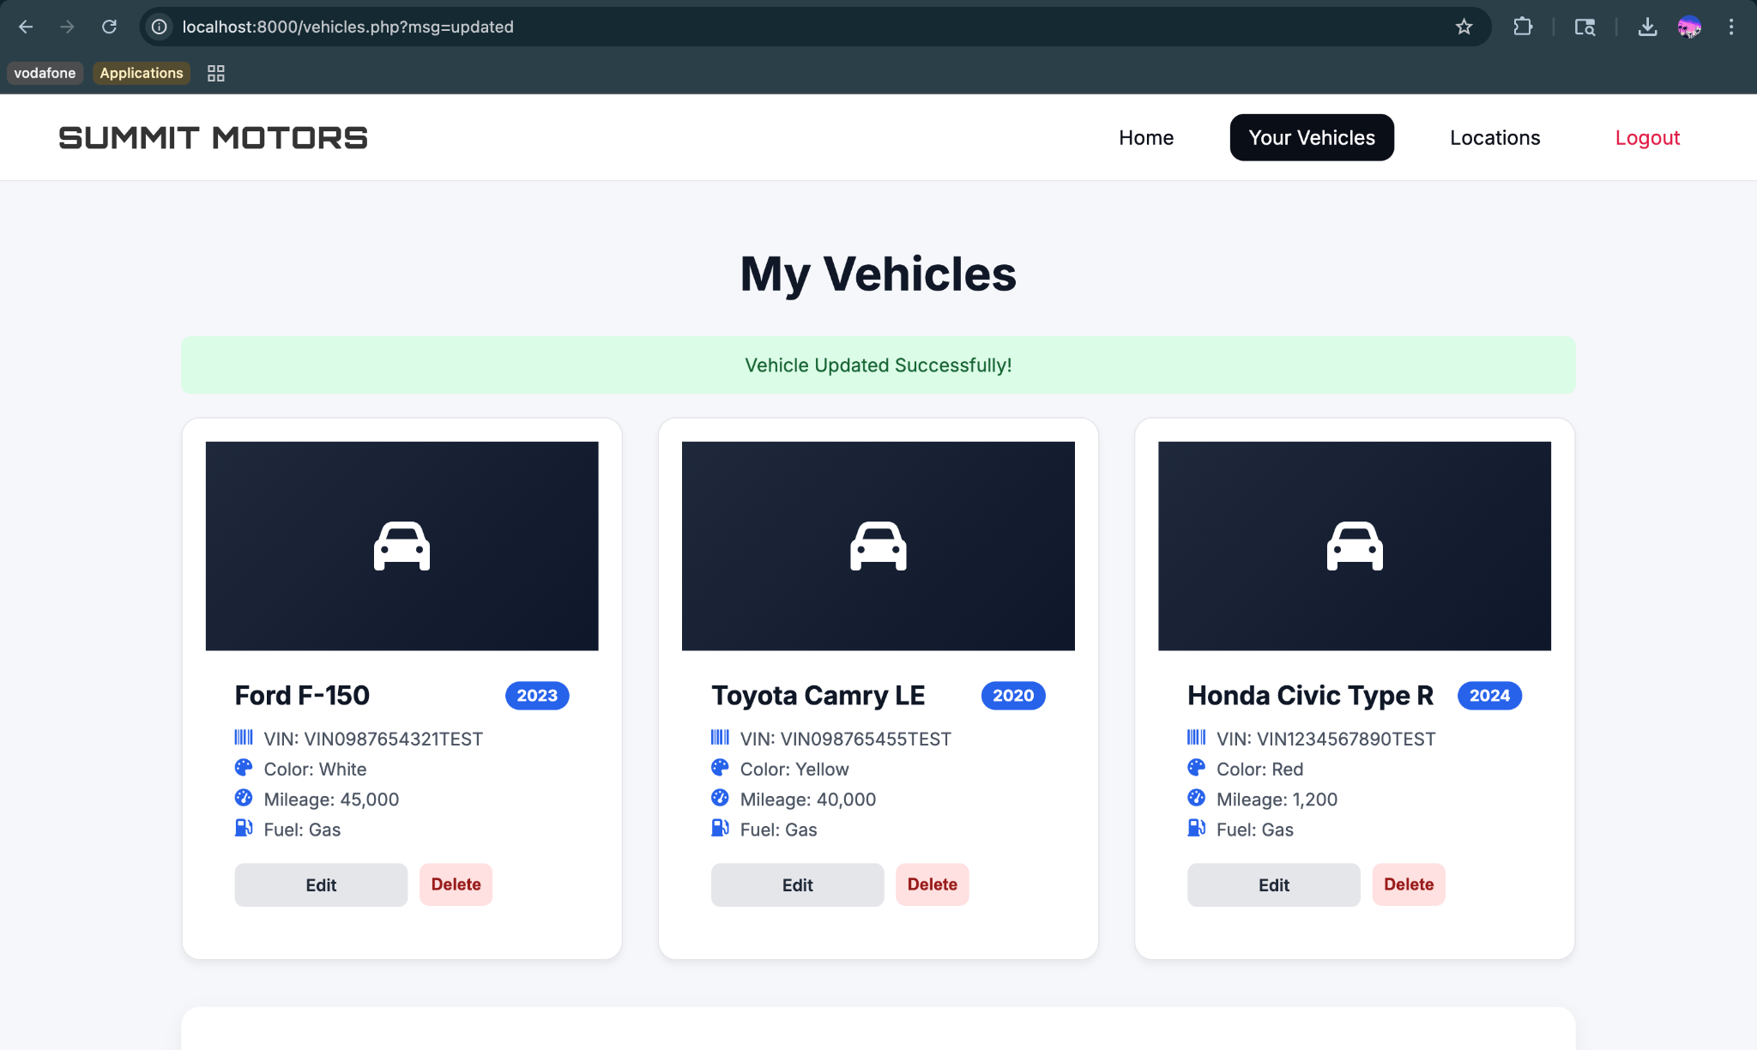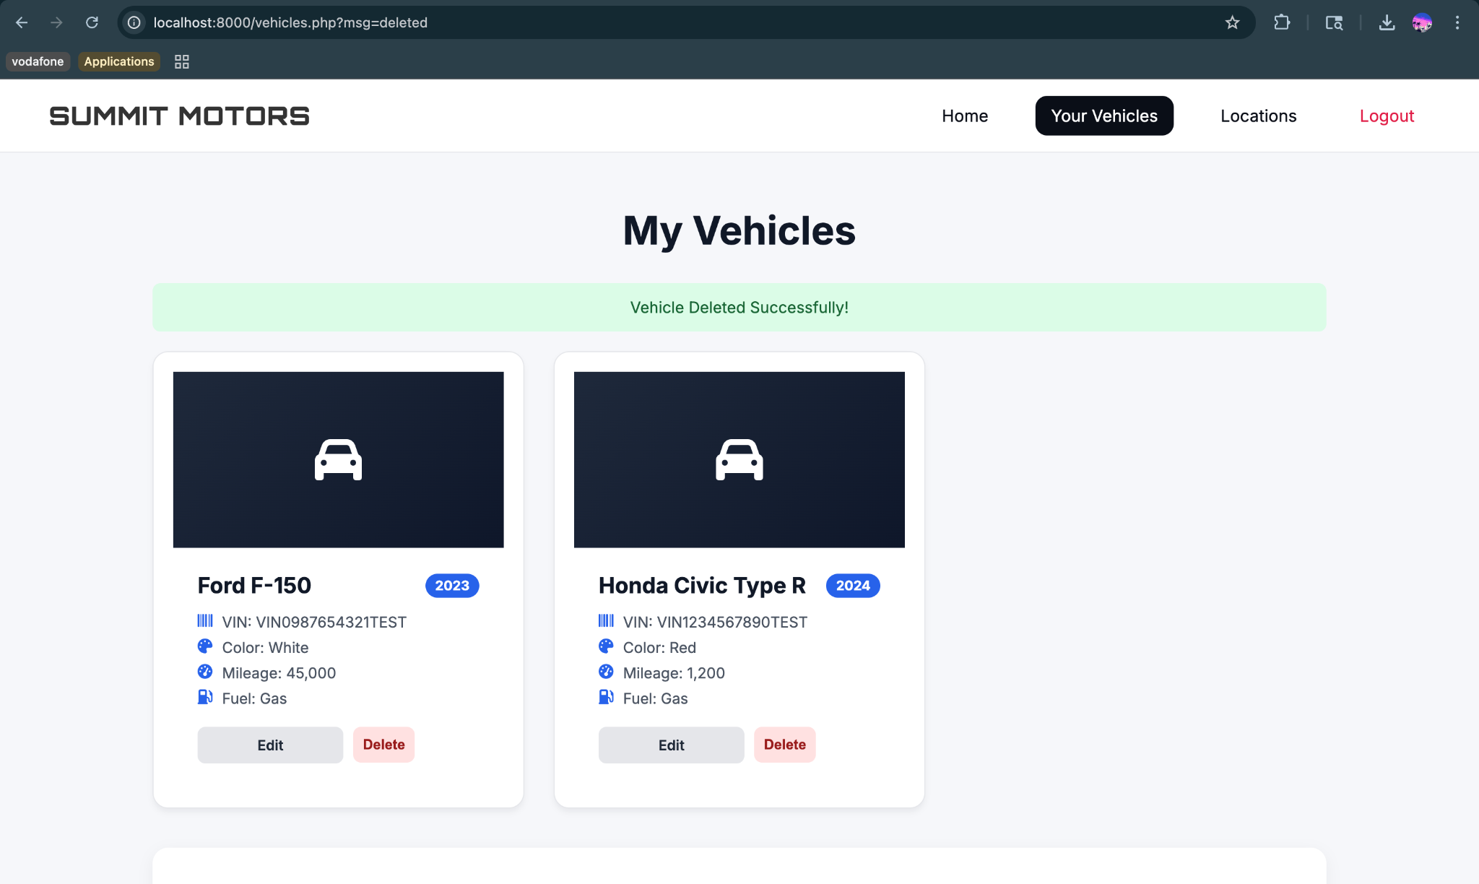

Figure 6: User's vehicle inventory retrieved from the database.

Figure 7: The "Add Vehicle" used to insert a new record into the database.

Figure 8: Interface for updating existing vehicle details (Blue → Yellow).

Figure 9: Deletion confirmation ensuring data integrity before removal.

# **Suggestions on Database Tuning**

List of suggestions for our database:

* Use appropriate data types such as use CHAR(17) for VIN (fixed length) and use YEAR for car manufacturing year
* Reduce NULL usage when possible such as Vehicle.make, Vehicle.model, and email
* Because the database stores SSNs, client financial data, vehicle ownership, and employee information, the following security enhancements are recommended:
  + Add user roles and permissions
  + Encrypt sensitive
  + Enforce strict password policies fields

# **User Application Interface**

The Summit Motors dealership interface was built using HTML for structure of each page, CSS to provide visual layout and responsive design, and PHP backend functionality for user authentication, data retrieval, and integration with the MySQL database. Users interact with the system through dedicated pages for login, registration, vehicle and service management, and employee tools/analytics.

***How Users Use the Summit Motors System***

To access the Summit Motors site dashboard, a user must first log in through the login page, where they must enter their email address and password. The system then verifies these credentials through the backend PHP authentication process to ensure that the given user email and password are found in the Summit Motors database. If the credentials do not match or if the user is not found, they can create an account by using the register page, otherwise, the system logs them in and redirects them to the main dashboard of Summit Motors. The following figure shows the layout and composition of the login page.

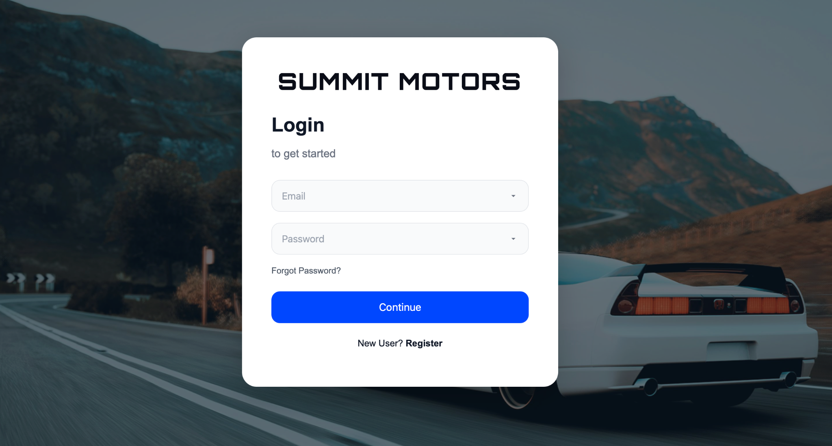

*Login Page of SUMMIT MOTORS*

Now if a user wants to create an account, they can access the registration page through the “Register” link located next to the “New User?” message. On this page, the user is asked to provide information such as their full name, address, state, date of birth, gender, social security number, email, phone number, and a password. Once they submit the form, the PHP program will validate all fields by checking valid formats and verifying that the social security number and email do not already exist in the database. After all inputs are verified and validated, the system will insert the new user’s information to the Summit Motors database, and then the user will be moved to the dealer dashboard.

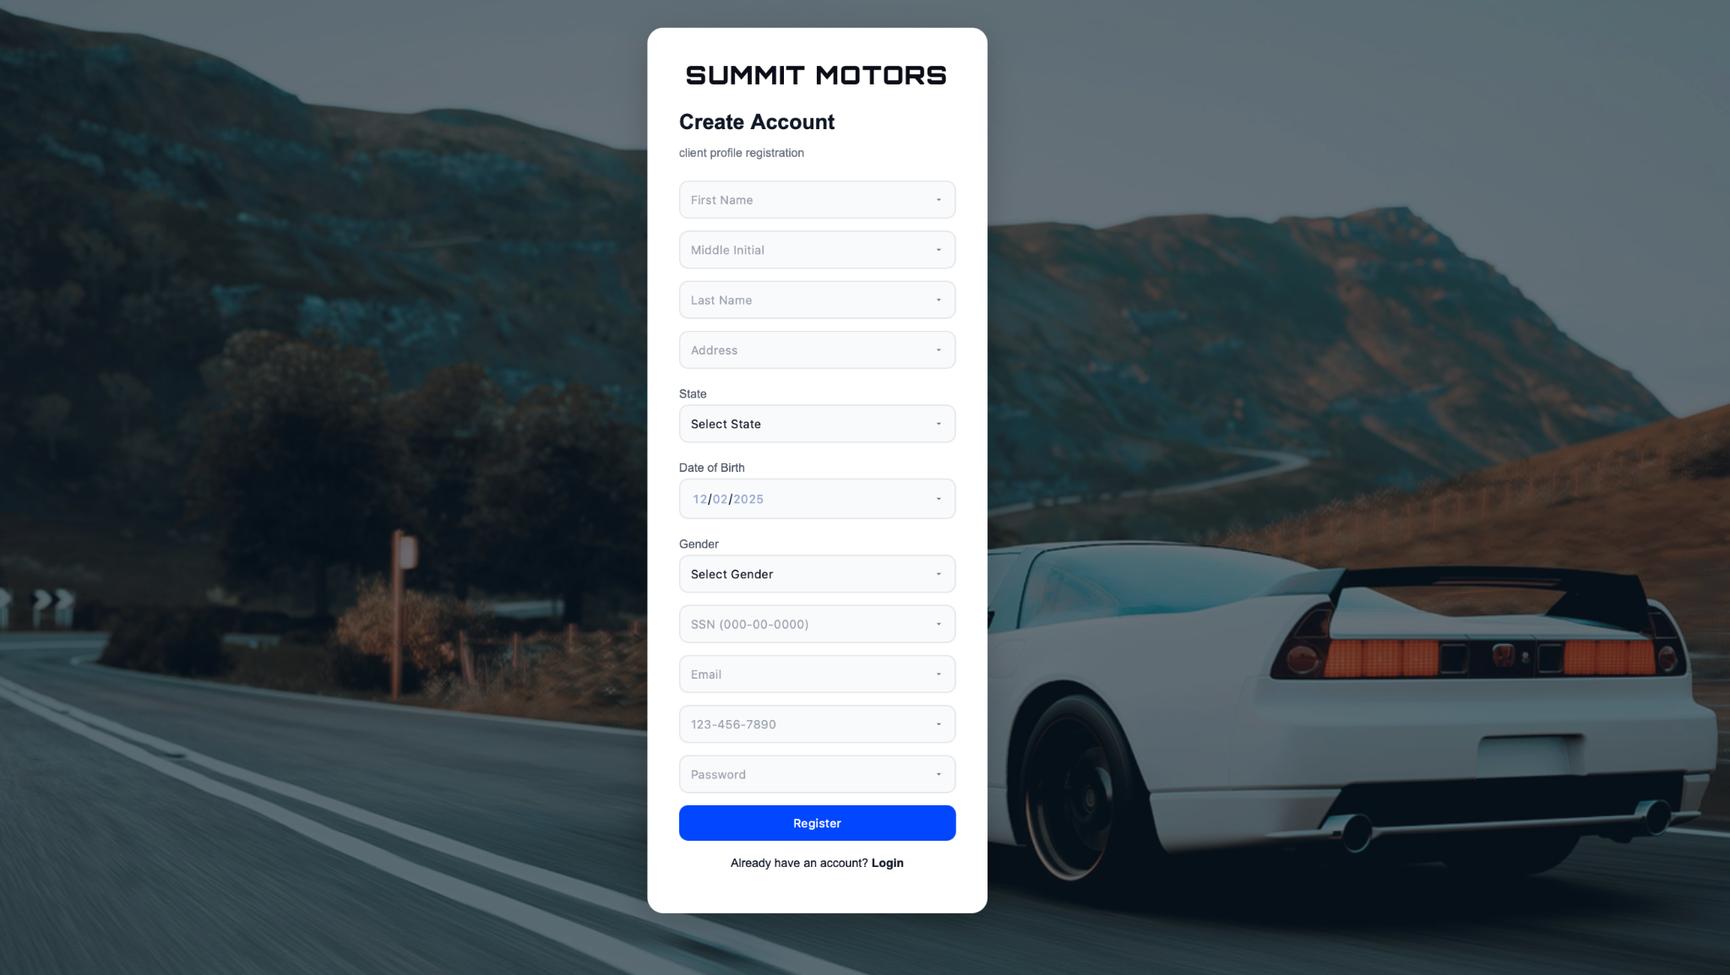

*Create Account Page of SUMMIT MOTORS*

After an account is registered to the Summit Motors database, a user will now be granted to access the Summit Motors client dashboard. On this page, the user can see general account information such as the total number of services completed, the number of vehicles associated with their account, and a list of recommended vehicles for sale. This page also includes a vin search tool to allow users to find more information relating to a vehicle.

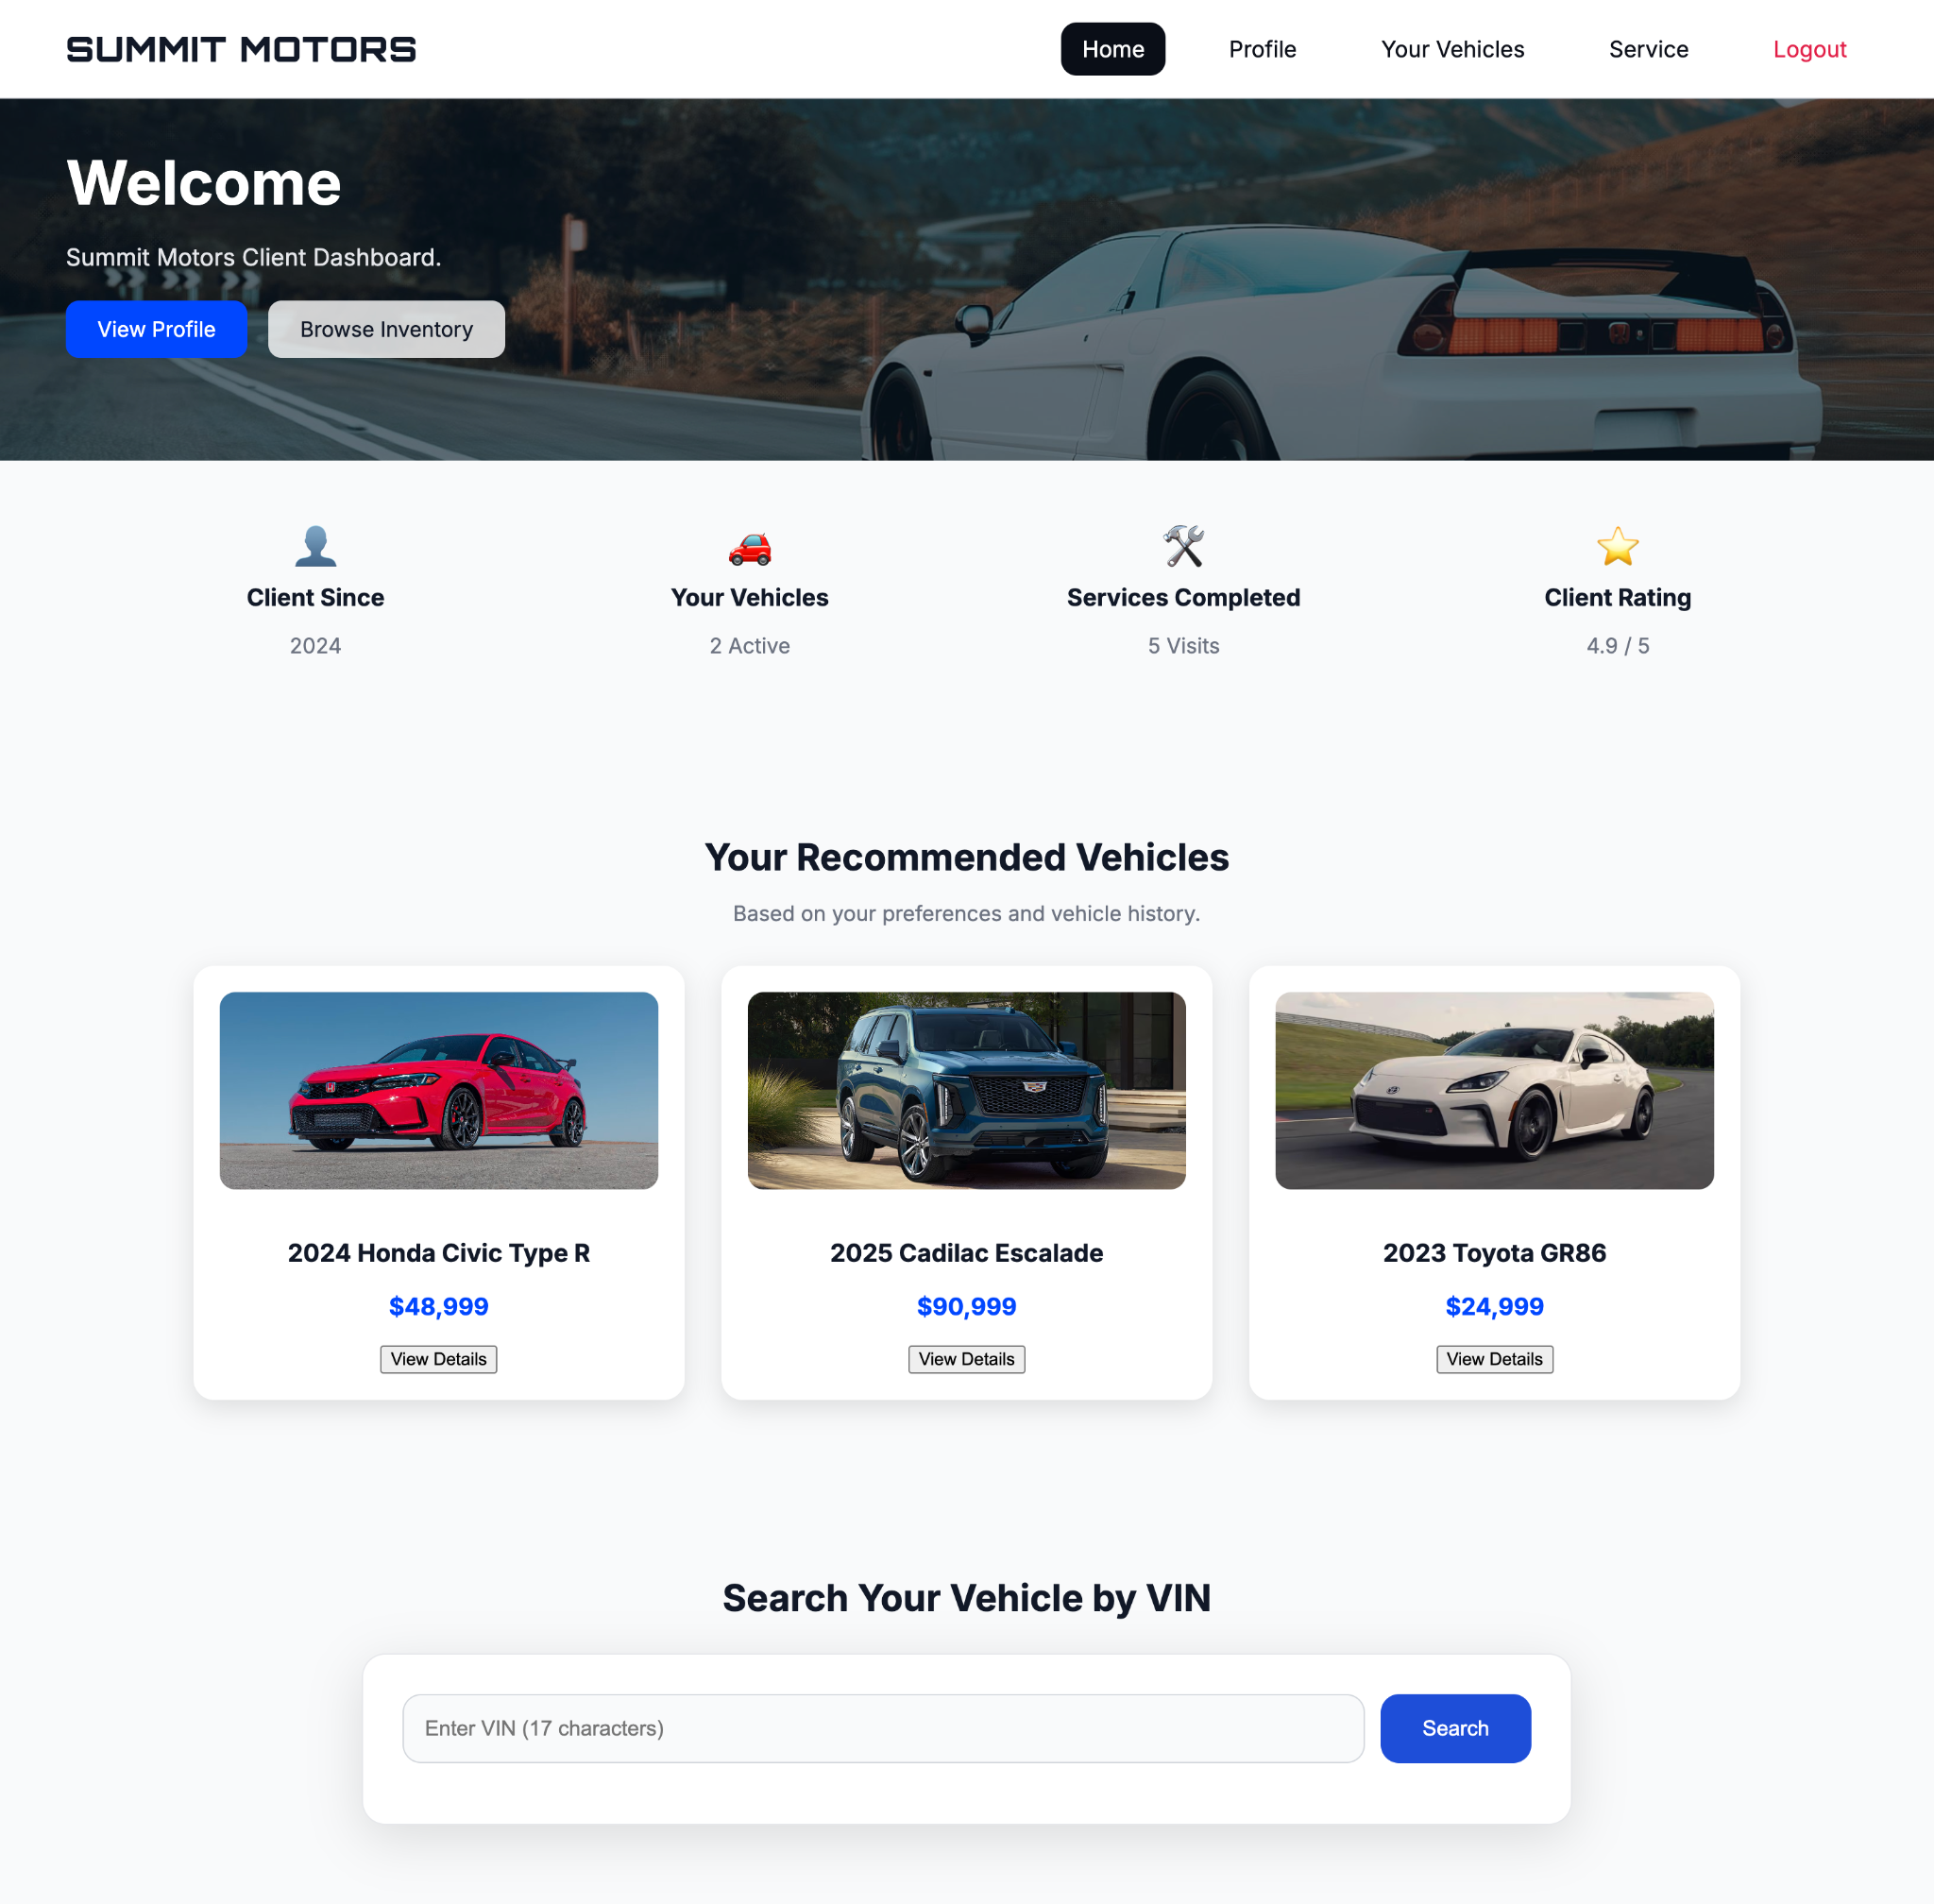

*Client Dashboard of SUMMIT MOTORS*

In the vehicle page, a user will be able to view all the vehicles linked to their account, showing details such as the make, model, vin number, color, mileage, engine, and transmission. Users will also be able to access the vehicle’s complete service history performed at Summit Motors. At the bottom of the page, there is the Add Vehicle section that allows users to register a new vehicle to their account by entering their car details.

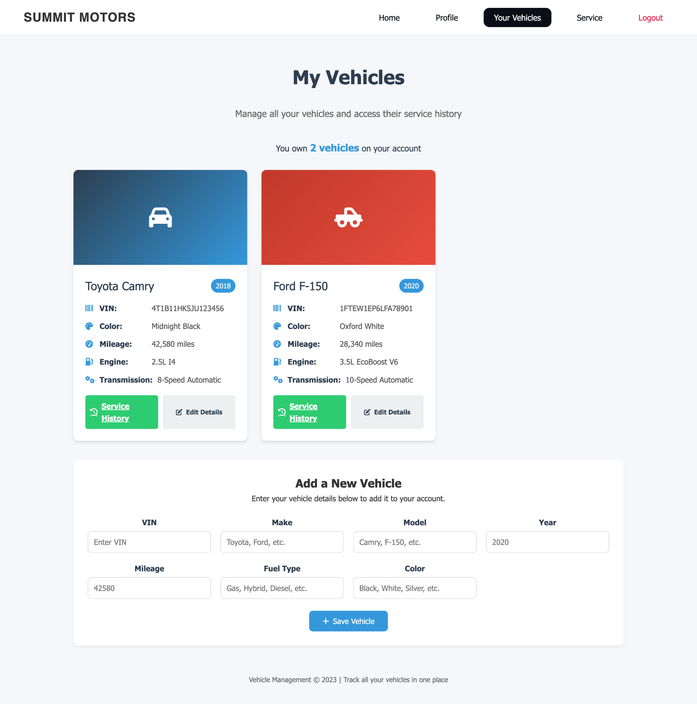

*Vehicle Dashboard of SUMMIT MOTORS*

The service page is where a user can view and manage all service appointments that have been completed or are upcoming for their vehicles. This page provides an overview of total services completed, total amount spent, and a detailed breakdown of each service. Each service entry includes the type of work performed, date, location, price charged, and mileage at service to allow the users to track their vehicle maintenance history.

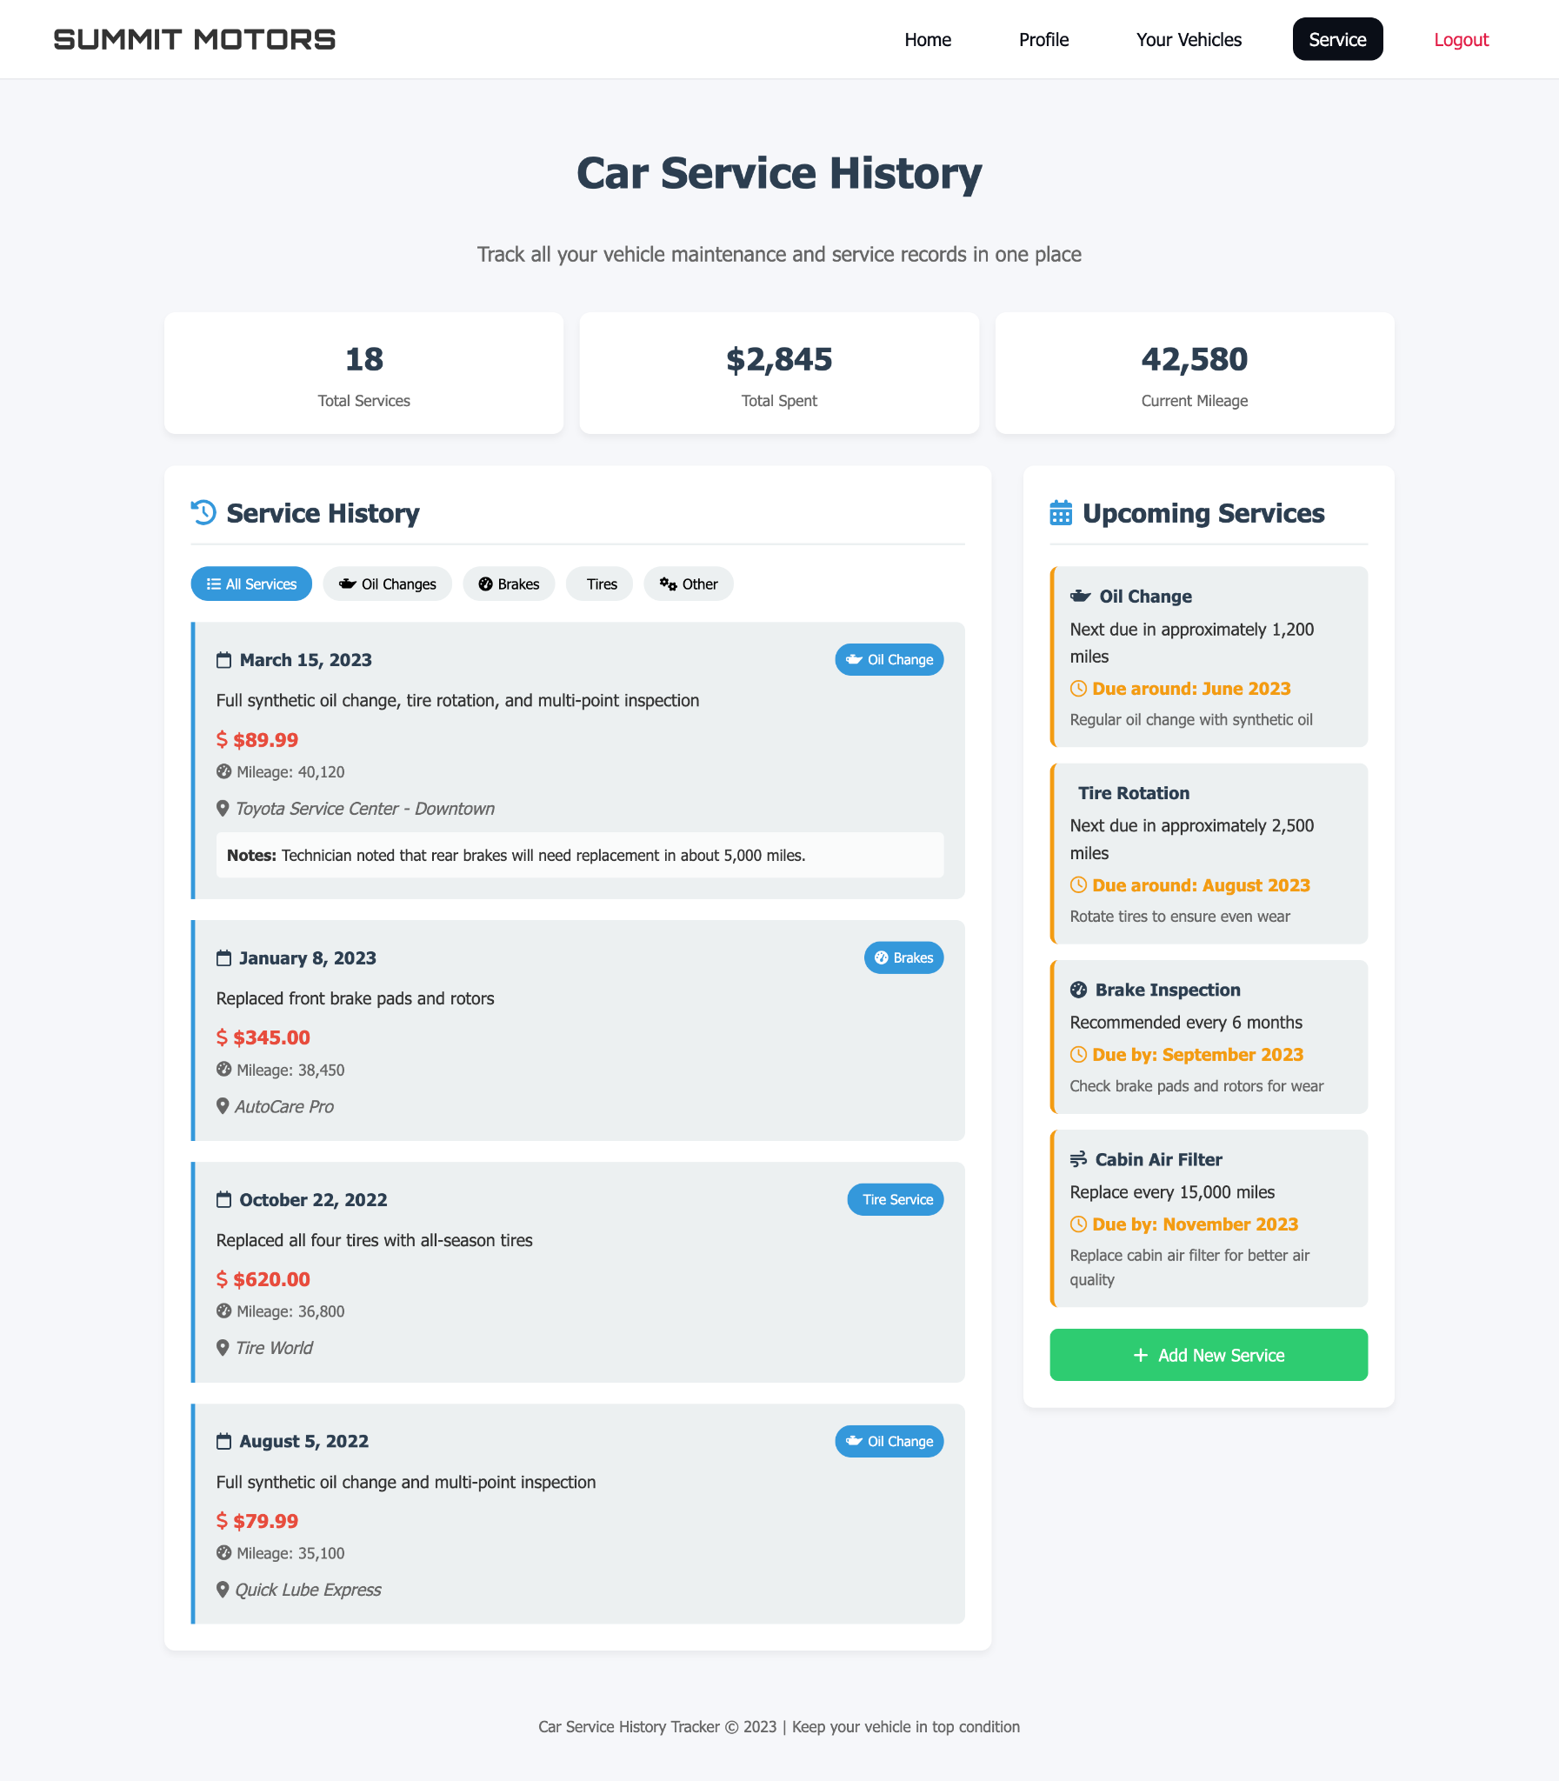

*Service Dashboard of SUMMIT MOTORS*

# **Conclusion and Future Work**

This project was an introduction of the full process of familiarizing ourselves with going from business rules to a finished, integrated web application. Starting with defining a use case, target audience, and having a problem statement gave our team a frame of reference to work off of when defining business rules. Then, those business rules being translated into an EER diagram allowed us to frame our business rules in the mind of a DBA, and taking it to the next step and converting them into relations allowed us to expose any complications and solidify interaction between the tables. Finally, normalizing and implementing these diagrams and relations helped our group go from concept to practice and have fun with creating interaction between dynamic web-forms and our database. In the future, implementing some of the suggestions mentioned on “Suggestions in Database Tuning” would be our first step. Then, we would find ways of automating database updates on detection triggers to lower human error.

# **References**

Class slides, lectures, textbooks

# **Appendix**

<https://drive.google.com/file/d/1cXsCErbdCPIFPAkN13pnxJfYZIdnG-oh/view?usp=sharing>